172.105.154.0- 172.105.154.255

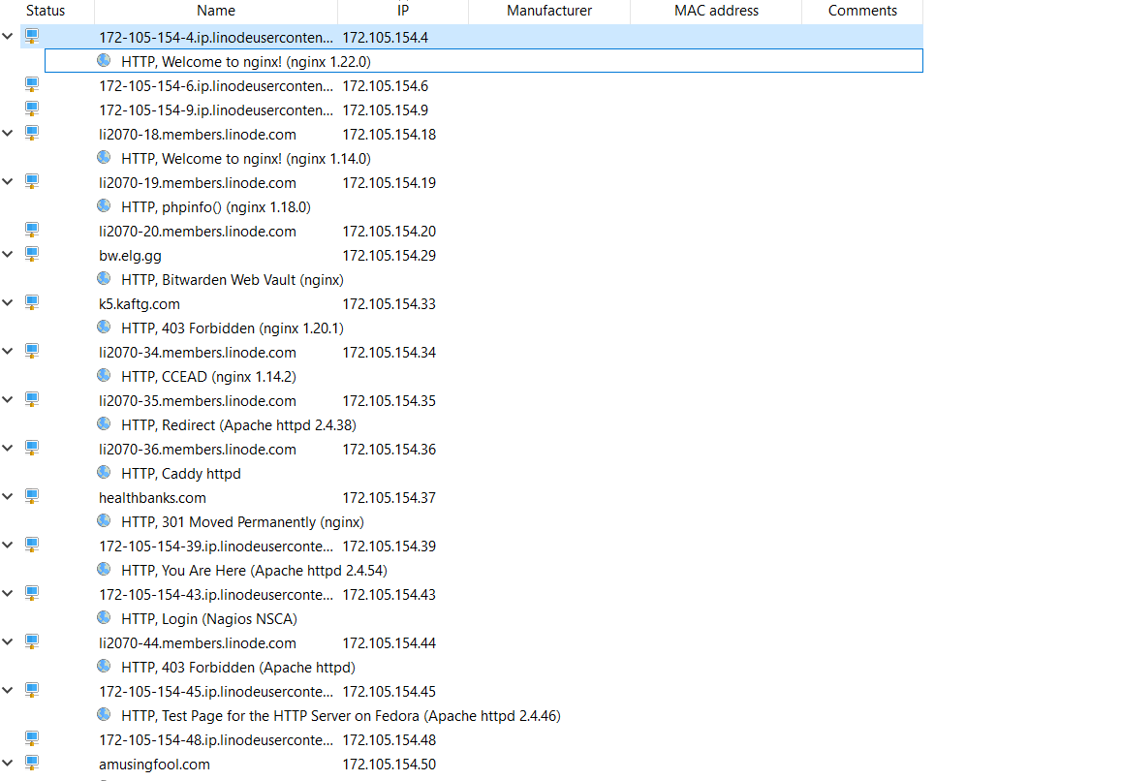

149.129.135.0-149.129.135.255

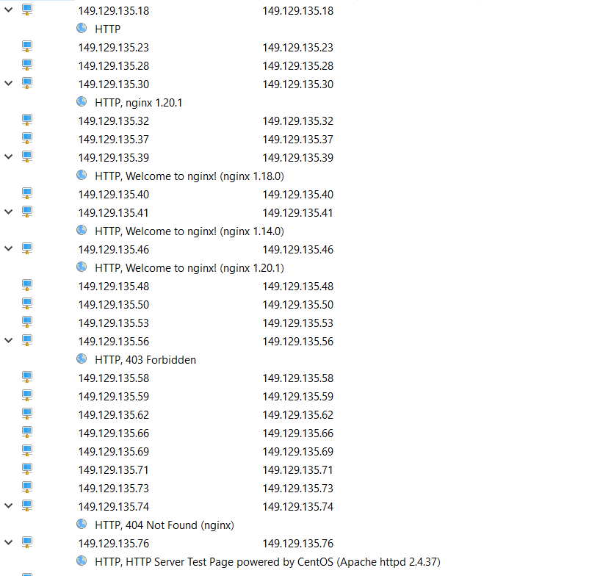

20.157.85.0-20.157.85.255

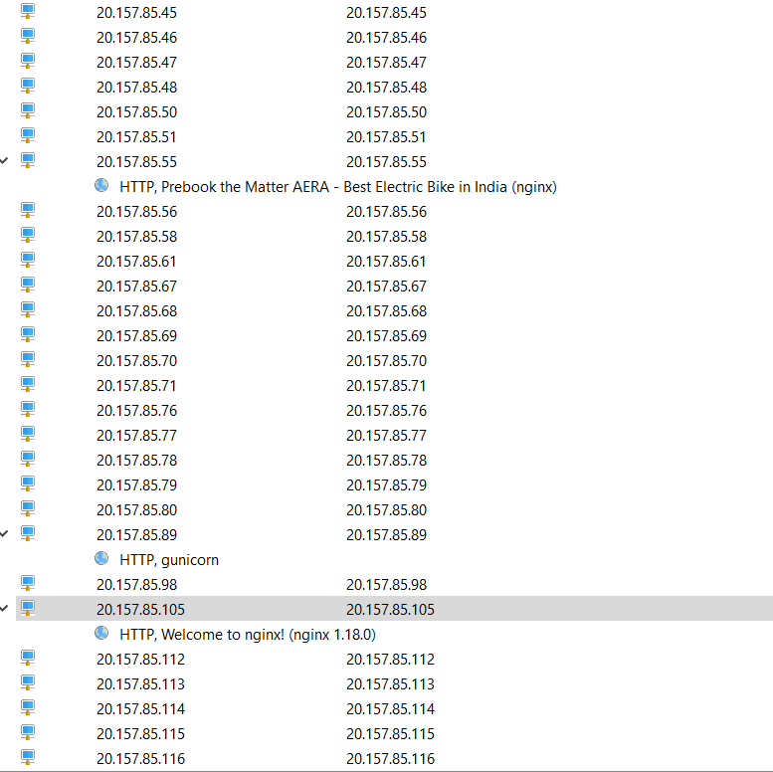

[**122.170.116.94**](https://www.shodan.io/host/122.170.116.94)

